## Sequence Diagram

## 

## Domain Model Diagram

## Class Diagram

## Data Flow Diagram

## Use case Diagram

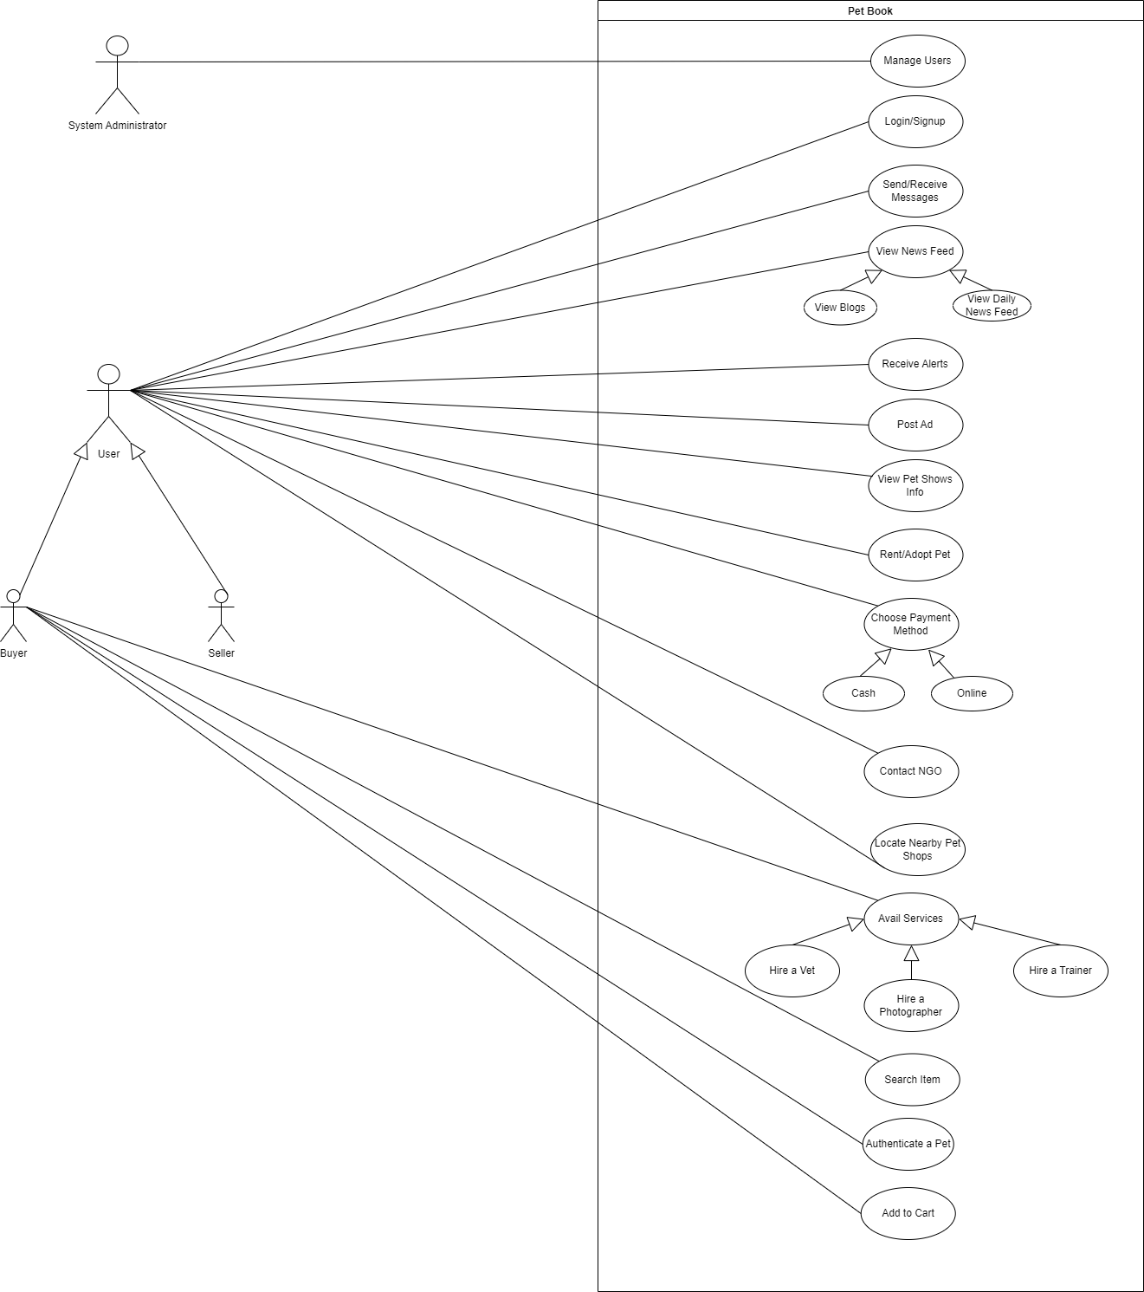

## ERD

